AFRICAN ANECDOTES
A member of the TAA (Tropical Agriculture Association) suggested that a book of African anecdotes could be compiled. John Harris, the current Chairman of BOAT, took up the challenge and the resulting book is now on sale.
Compiling and editing the stories from 31 contributors (mostly south-west based) has been very much a labour of love through the lockdowns. Of the 52 countries on the continent, there are pieces from 25 of them, covering everything from people to politicians, farming to folklore, snakes to security forces, and weather to wildlife - some are very short and none is too long. There is something to interest everybody.
The independent reviews have yet to appear, but those who have read the book so far have enjoyed it. By reading it, they have contributed to the Trust’s fundraising.
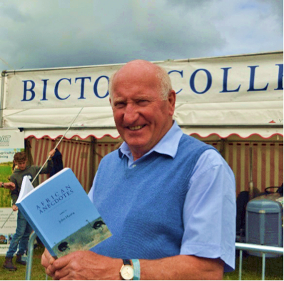
ORDER FORM
Orders to: secretary@boatagtrust.co.uk
OR: BOAT, c/o 8 Slade Close, Ottery St. Mary, Exeter EX11 1SX
Name
Address
No. of copies (@ £15.98 each, including p&p)
Cheques made payable to ‘Bicton Overseas Agricultural Trust’
OR: try the online shop https://bicton-overseas-agricultural-trust.sumupstore.com

